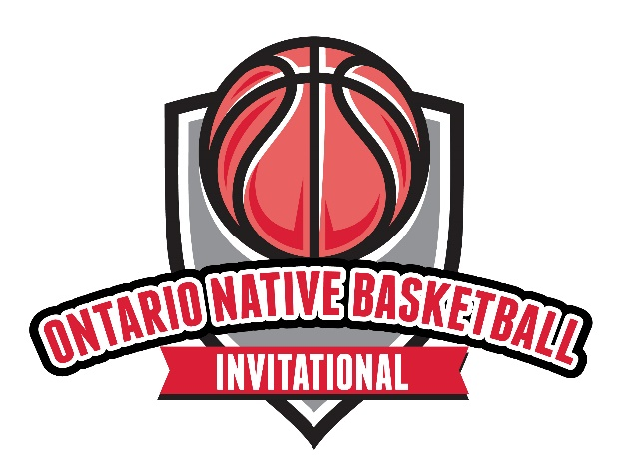

MEDIA WAIVER

By your direct and indirect participation (“Your Participation”) in participating in the “2023 Ontario Native Basketball Invitational (ONBI)” (the “Event”) organized and hosted by the Indigenous Sport & Wellness Ontario (“ISWO”), you agree and consent to interview(s), photography, audio recording, video recording that depict and display Your Participation in the Event (the “Media Materials”) and further agree to the Media Materials’ release, dissemination, exploitation, publication, exhibition, or reproduction for use for news, webcasts, promotional purposes, telecasts, advertising, inclusion on websites, social media, or any other purpose (hereinafter collectively referred to as the “ISWO’s Usages”) by ISWO and its affiliates, agents and representatives. You further agree that Your Participation shall be deemed as your full agreement and authorization to ISWO (“Your Grant”) of the right and licence to use (“Your Grant”), without payment of any fee, charge, or compensation of any kind, including royalties, to you of the Media Materials and any and all written information about you taken during the Event for promotional purposes, and that you also agree to waive (“Your Waiver”) any right to approve ISWO’s Usages of the Promotional Material, now and in the future. You further specifically agree and acknowledge that images, photos and/or videos of you contained and referenced in the Media Materials may be used to: promote ONBI or other ISWO events in the future; highlight and showcase the Event and exhibit the operational capabilities of ISWO.

You agree that by Your Participation, any photograph, work expressed by any process analogous to photography, video or cinematographic film produced by, at the request or under the direction or control of ISWO or under its supervision during the Event and in which you appear may be indefinitely used, reused, adapted, altered, cropped, produced, reproduced, published, republished, distributed to the public, communicated to the public by telecommunication, publicly presented as a cinematographic work, presented at a public exhibition, preserved, conserved or archived by ISWO its representatives, assigns, employees and agents and any person acting under ISWO’s authority, for any purpose related to ISWO’s promotion of the Event or other ISWO programs throughout the world including but not limited to, any publication, broadcast posting on the Internet (Web) advertising or display.

You agree and acknowledge have you have been fully informed of Your Grant, Your Waiver and the ambit of ISWO’s Usages, before entering the Event and understand the effect of Your Grant, Your Waiver and the ambit of the ISWO’s Usages.

