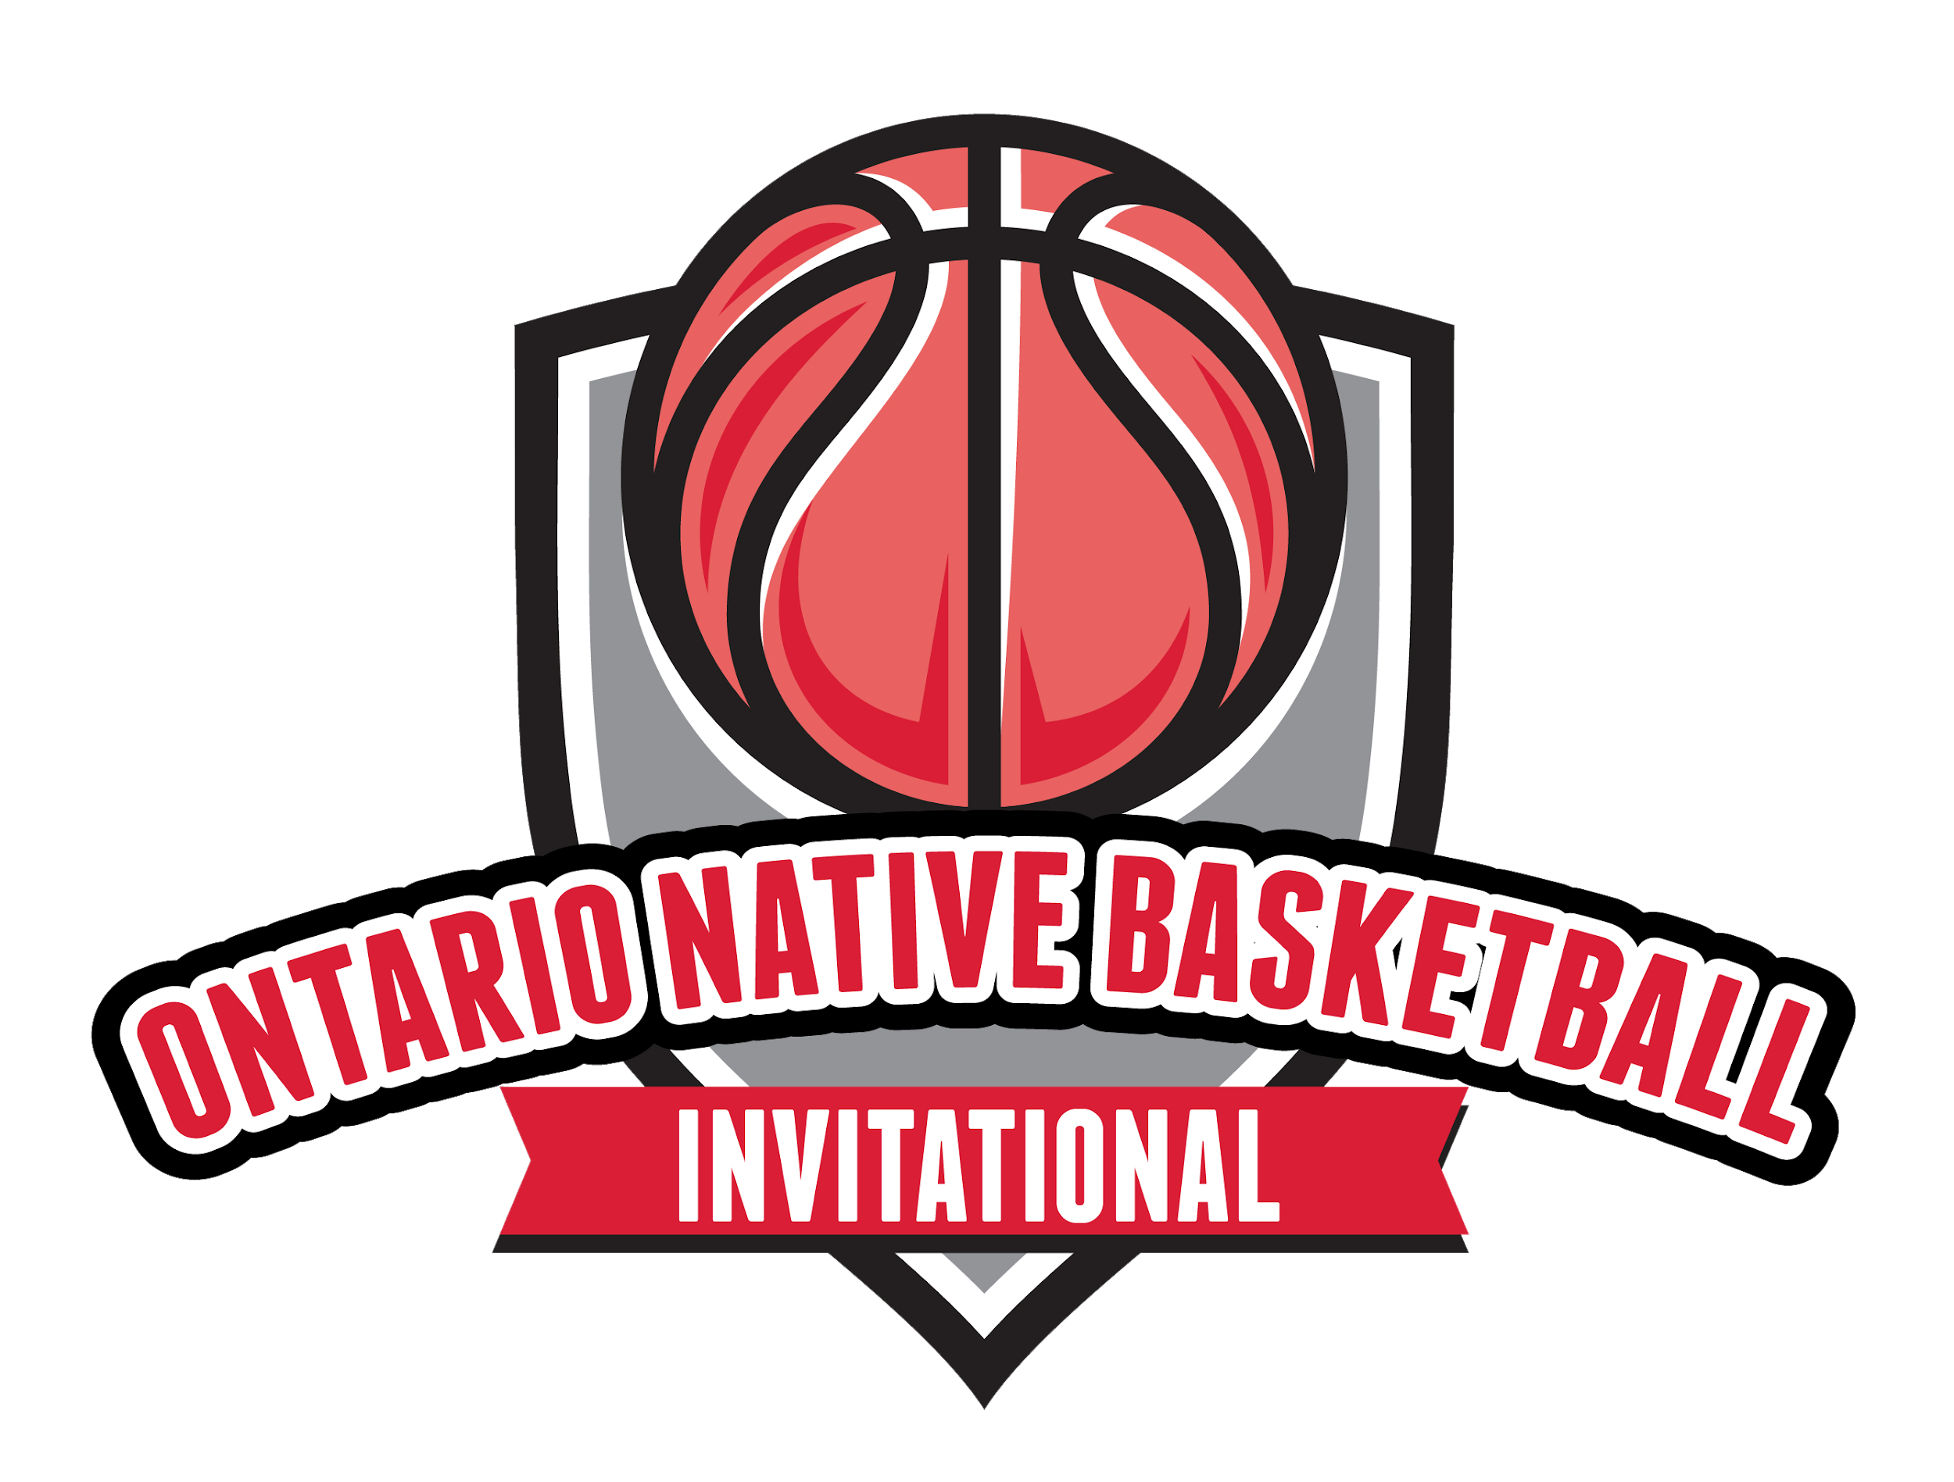
2023 Ontario Native Basketball Invitational (ONBI)
Participant Code of Conduct
□ Exemplify honesty, integrity and fair play no matter what the circumstance.
□ Honor the spirit and the letter of the rules. Promote sportsmanship over gamesmanship.
□ Treat members of your team, other teams, officials, coaches, the audience, volunteers, organizers, and all individuals with respect and dignity.
□ Not engage in or permit profanity or obscene gestures.
□ Not use physical or psychological intimidation or verbal abuse toward players.
□ Not use or consume alcohol, illegal drugs, marijuana (in any form) and tobacco products (including vaping and e-cigarettes) while taking part in the 2023 ONBI.
□ Respect and protect the facilities where you play games or engage in activities sponsored by the host organization. You will report to your parents/coach/chaperone any damage that occurs that you witness. Remember that you are a representative of your community during your stay.
□ Ensure all equipment is treated with respect. Under no circumstances are participants approved to alter or change equipment without prior consent.
□ Understand the rules of the game as appropriate for age and competitive level of the team.
□ Zero tolerance for violence, abuse or hazing of any nature.
□ Not ridicule or yell at a teammate or other participant for making a mistake or losing a competition.
□ Will respect and abide by the instructions from and the decisions of the organizing committee with respect to: concussion protocols; injury decisions including removal from play, reduced or modified participation; safety instructions including implementation of crisis/emergency protocol; and any other safety related situations.

Consequences
ANY conduct detrimental to the team or individuals on the team, and/or any violation of ISWO policies or guidelines, will present the coach with no option but to enforce the disciplinary actions available to them. These disciplinary actions can include "benching", ineligibility for games, or even removal from the team. It is agreed that, under the established guidelines, both the player and the parent/guardian/chaperone will accept what the coach feels is appropriate discipline.
When it is reported in writing that a participant has broken the code of conduct, tournament organizers and officials will investigate and discuss with all parties. Disciplinary actions can include, but are not limited to:
- Verbal warning by official, head coach, and/or members of the organizing committee.
- Written warning.
- Game suspension with written documentation of incident kept on file.
- Game forfeit through the official or coach.
- Player or Coaching suspension for participation in the tournament.
- Lifetime ban from the ONBI and other ISWO tournaments and games in relation to Team Ontario.

I have read the above code of conduct and agree to the terms of conduct as described above.

