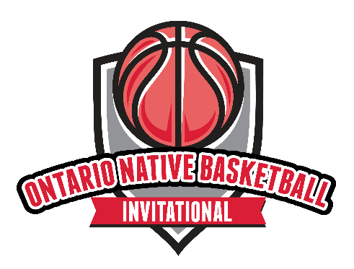
PARTICIPATION WAIVER

In consideration of being permitted by Indigenous Sport & Wellness Ontario (“ISWO”) to participate in activities for the “2023 Ontario Native Basketball Invitational” (the “Event”), I hereby waive, release and discharge any and all claims for damage for personal injury, death or property damage which I may have, or which may hereafter accrue to me, as a result of my participation in any and all activities offered, described, demonstrated, instructed, recommended and, or encouraged (the “Event Activities”) whether through commentary or visual display by ISWO through the Event. This form of release (the “Release”) is intended to discharge in advance ISWO, its officers, employees and agents (the “Releasees”) from any and all liability arising out of or connected in any way with my participation in any of the Event Activities that is related to, raised, discussed, showcased, demonstrated, promoted, displayed, encouraged or commented on during or through the dissemination of the Event even though that liability may arise out of negligence or carelessness on the part the Releasees. It is understood that the Event Activities that I will be participating in involve an element of risk and danger of accidents and knowing those risks, I hereby assume those risks. It is further agreed that this Release and assumption of risk is to be binding on my heirs and assigns. I agree to indemnify and to hold harmless, the Releasees from any loss, liability, damage, cost or expense which they may incur as the result of my death or any injury or property damage that I may sustain while participating in the Event Activities. I further agree that this Release and any rights, duties and obligations as between myself and the Releasees shall be governed by and interpreted solely in accordance with the laws of the Province of Ontario and no other jurisdiction, and any litigation involving this Release shall be brought solely within the Province of Ontario and shall be within the exclusive jurisdiction of the Courts of Ontario. I acknowledge that in entering into and accepting this Release I am not relying on any oral or written representations or statements made by the Releasees with respect to the safety of participating in the Event Activities.

I acknowledge that COVID-19 is contagious and is believed to spread mainly from person-to-person contact. As a result, federal, provincial, and local governments and federal and provincial health agencies recommend social distancing and have, in many locations, prohibited the congregation of groups of people (such restrictions are hereinafter collectively referred to as the “Prevailing Government Health Guidelines”). I acknowledge that I will adhere to the Prevailing l Government Health Guidelines during my participation in the Event Activities and further acknowledge that ISWO is strongly advising and directing that all participants in the Event Activities fully comply with the Prevailing Government Health
Guidelines and in the event that full or material compliance and adherence with the Prevailing Government Health Guidelines is impossible or impracticable, that it is ISWO’s direction and advice that I should not participate in the Event Activities. I understand and acknowledge that participation in Event
Activities without compliance with the Prevailing Health Guidelines may expose me to possible exposure to and illness from infectious diseases, including COVID-19. Therefore, in consideration of being permitted to enter and participate in Event Activities, I acknowledge the contagious nature of COVID-19 and the risk of injury that may result from exposure or infection to the same if I do not comply with Prevailing Government Health Guidelines and voluntarily agree to assume these risks and accept sole responsibility for any injury to myself or my child(ren) including, but not limited to, personal injury, disability, death, illness, damage, loss, claim, liability, or expense, of any kind (hereinafter collectively referred to as the “Possible Claims”), that I or my child(ren) may experience or incur in connection with my or my child(ren)’s attendance and participation at the Event Activities in circumstances where the Prevailing Government Health Guidelines are not complied with. On my behalf, and on behalf of my children who are participating in the Event Activities, I hereby release, covenant not to sue, discharge, and hold harmless the Releasees, of and from the Possible Claims, including all liabilities, claims, actions, damages, costs or expenses of any kind arising out of or relating thereto. I understand and agree that this Release includes any Possible Claims based on the actions, omissions, or negligence of the Releasees, whether a COVID-19 infection occurs before, during, or after participation in Event Activities where the Prevailing Government Health Guidelines are not complied with or from any injury, claim for damages or loss otherwise arising or resulting from my or my children’s direct or indirect participation in the Event Activities. I further expressly agree that the Release and foregoing assumption of risk and waiver is intended to be as broad and inclusive as is permitted by the laws of the Province of Ontario and common law and that if any portion thereof is held invalid, it is agreed that the balance shall, notwithstanding, continue in full legal force and effect.

I have carefully read and voluntarily sign this Release, assumption of risk and waiver of liability, with respect to the risks of contracting a COVID-19 infection or from any other injury, claim for damages or loss otherwise arising or resulting from my or my children’s direct or indirect participation in the Event Activities. I further agree and acknowledge that no oral representations, statements or inducement apart from the foregoing written agreement has been made or advanced by the Releasees or any other party that induced me to accept and agree to this Release. I further agree and acknowledge that have read and understood the Release prior to accepting the terms of the Release, and I am aware that by accepting this Release I am waiving certain legal rights which I or my heirs, next of kin, executors, administrators, assigns and representatives may have against the Releasees with respect to the risks of contracting a COVID-19 infection or from any other injury, claim for damages or loss otherwise arising or resulting from my or my children’s direct or indirect participation in the Event Activities.

